Human Resource Management
Project Resource Management (previously called Human Resource Management in older PMBOK editions) involves processes to identify, acquire, and manage resources (human and physical) needed for successful project completion.
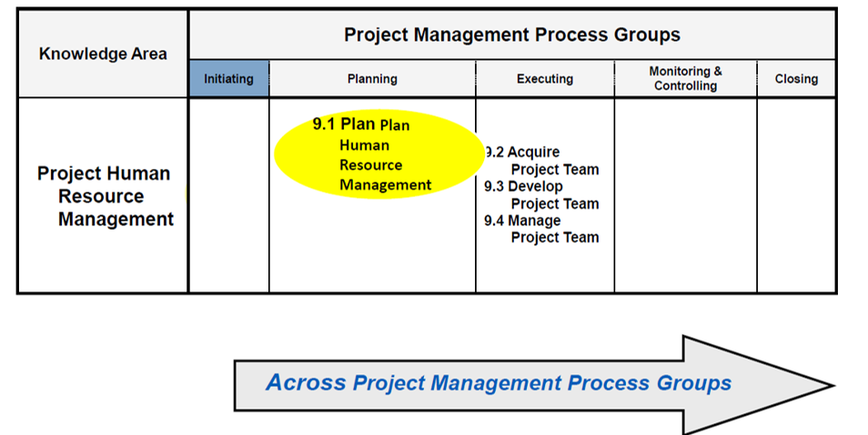
Key Processes
Plan Resource Management
- Purpose: Define how to estimate, acquire, manage, and use resources.
- Input: Project charter, project management plan, EEFs, OPAs.
- Outputs: Resource Management Plan, Team Charter.
- Example: Creating a plan that specifies roles, responsibilities, and reporting relationships for a software development project.
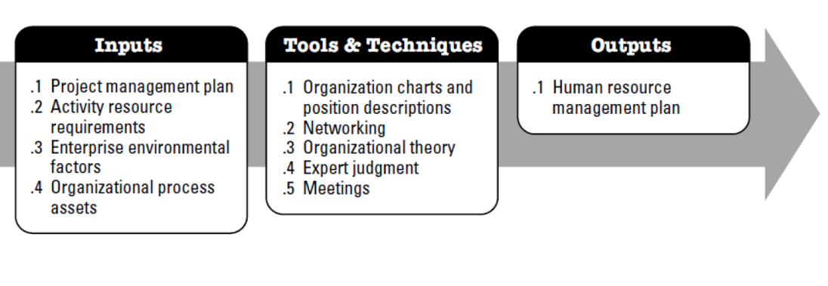
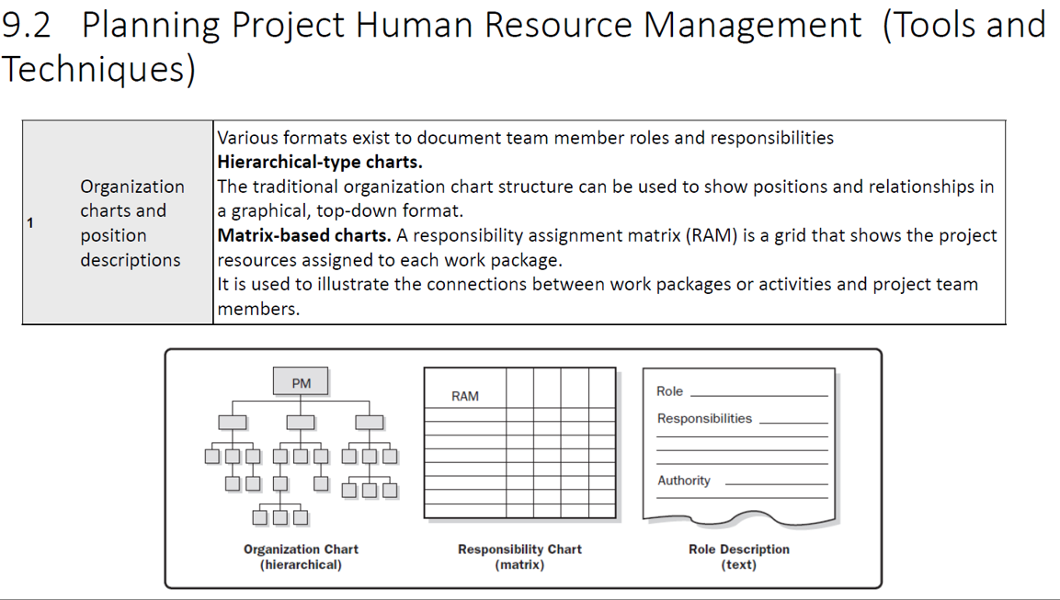
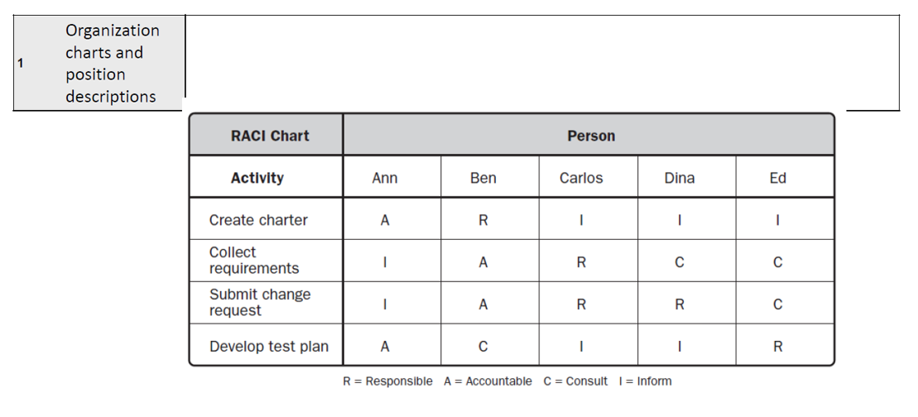
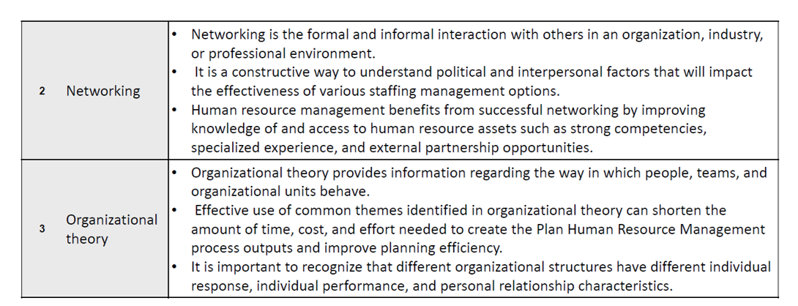
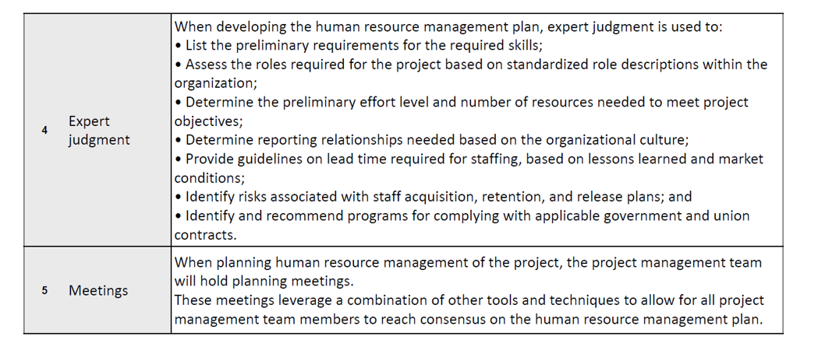

Estimate Activity Resources
- Purpose: Estimate type and quantity of resources (people, equipment, materials).
- Tools: Expert judgment, bottom-up estimating.
- Example: For a mobile app project, estimate 2 developers, 1 QA engineer, and 1 UI/UX designer for 3 months.
Acquire Resources
- Purpose: Obtain team members and physical resources.
- Tools: Negotiation, pre-assignment.
- Example: Negotiating with a functional manager to allocate a senior developer to your project.
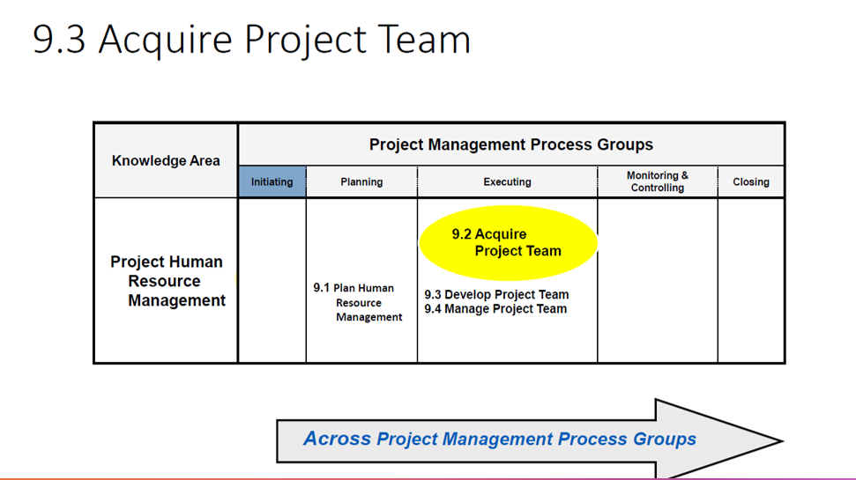
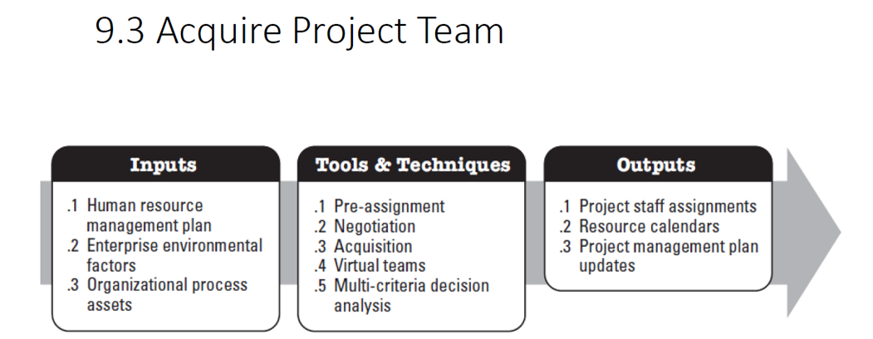
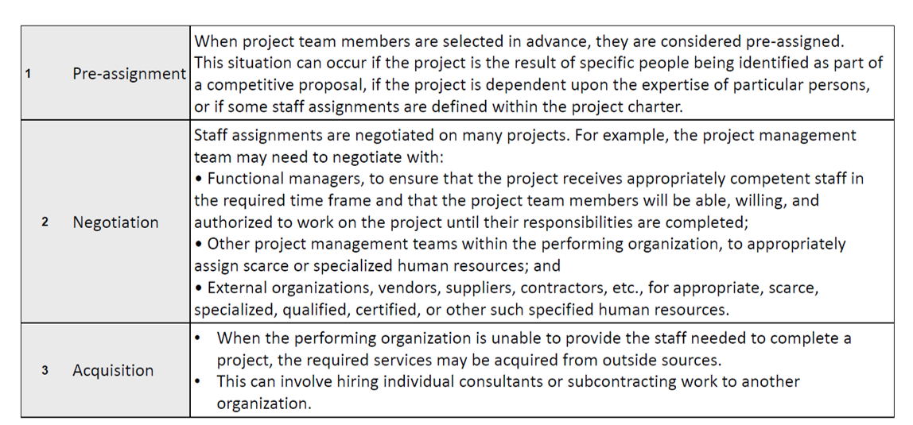
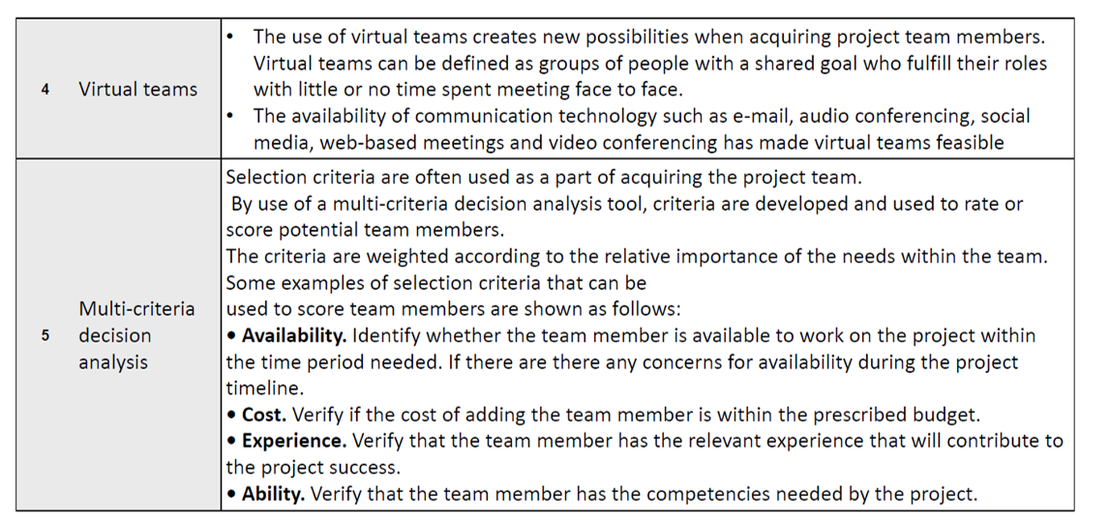
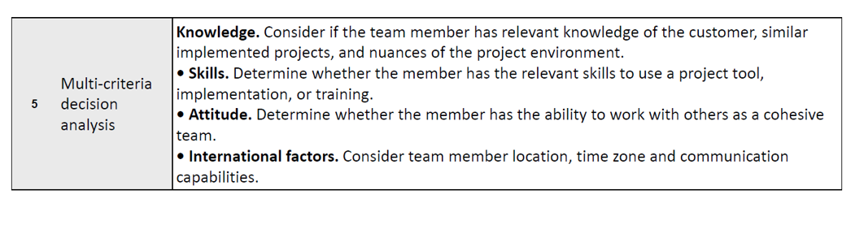
Develop Team
- Purpose: Improve competencies, team interaction, and overall environment.
- Tools: Training, team-building activities, recognition and rewards.
- Example: Conducting an Agile workshop for the team to improve collaboration.
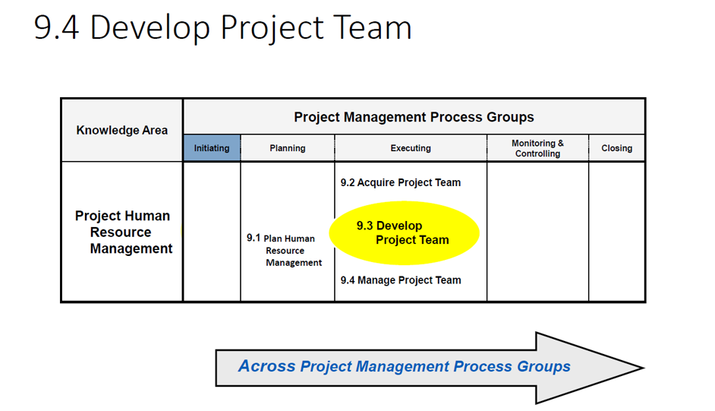
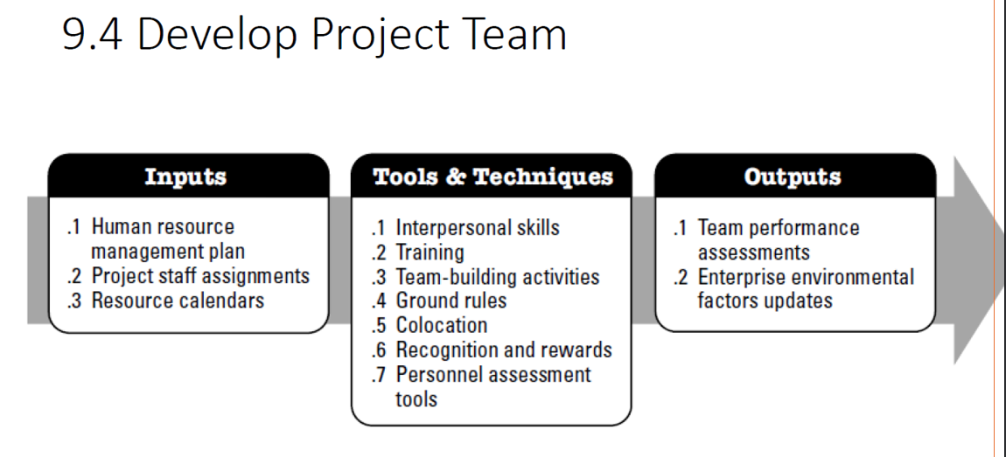
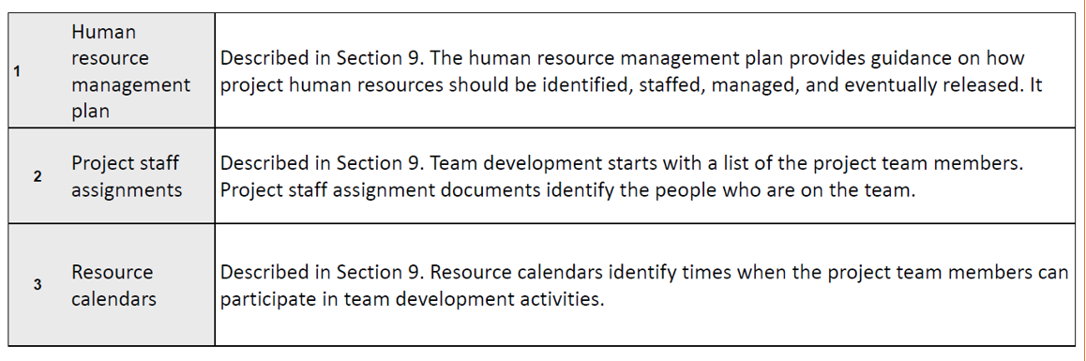
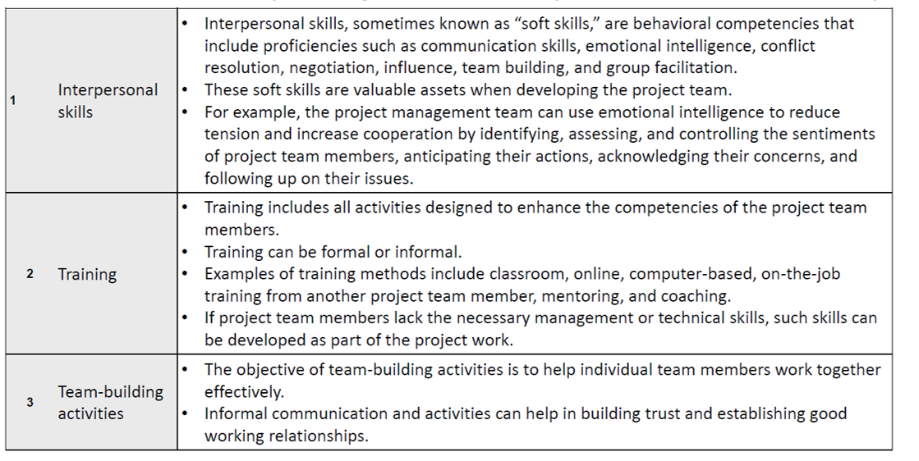
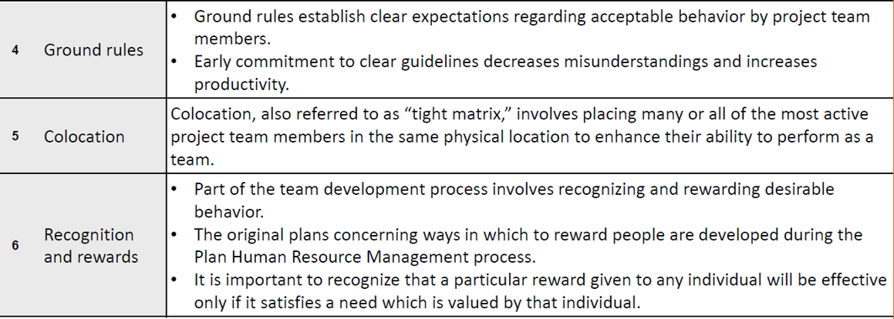
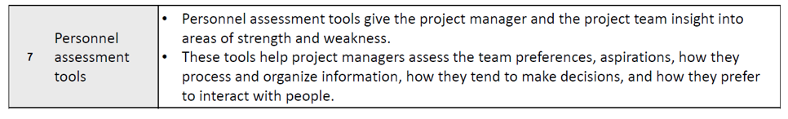
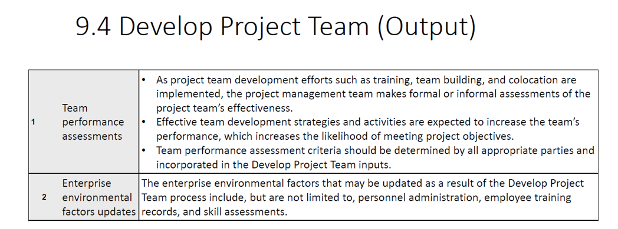

Manage Team
- Purpose: Track performance, provide feedback, resolve issues.
- Tools: Conflict management, performance appraisals.
- Example: Resolving a conflict between a developer and QA over bug prioritization.
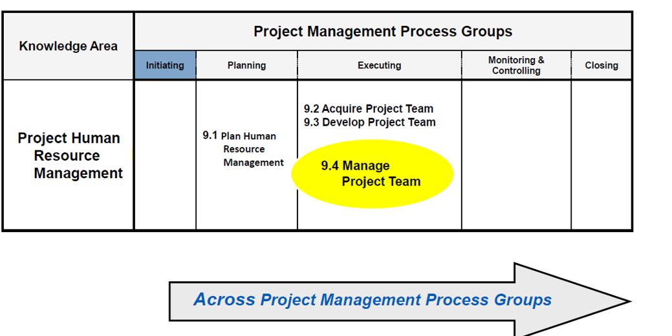
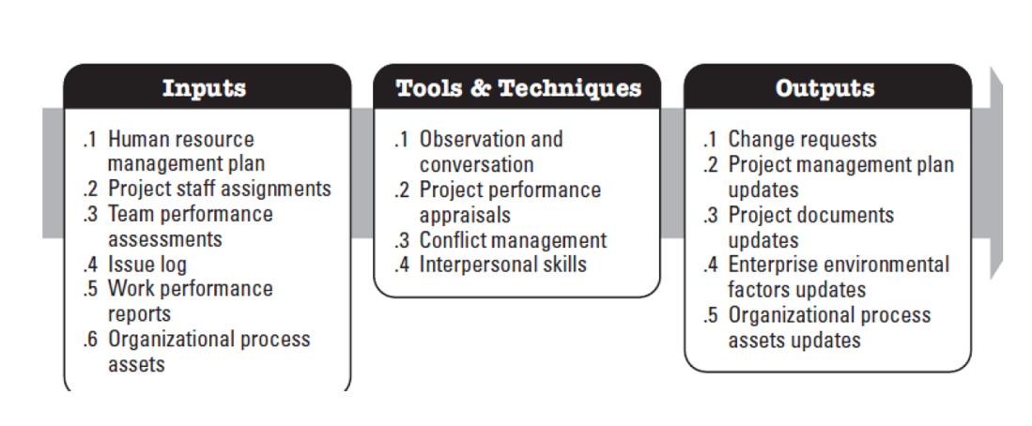
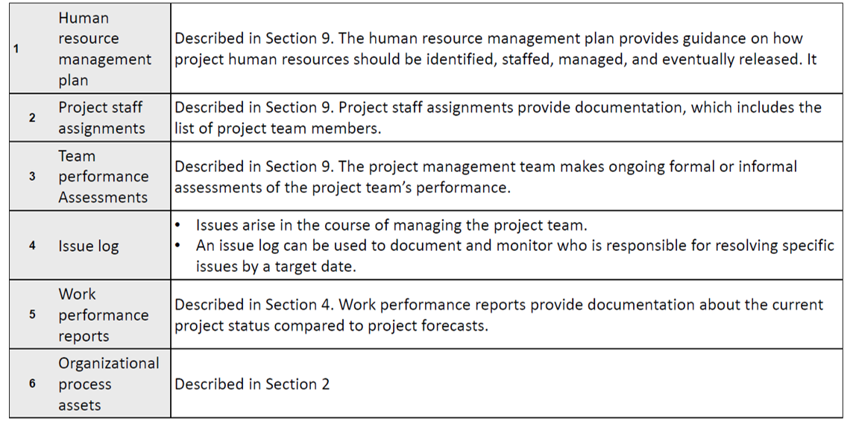
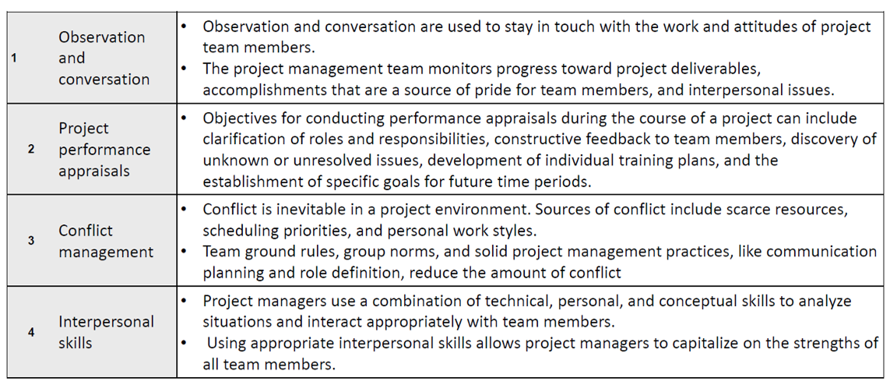
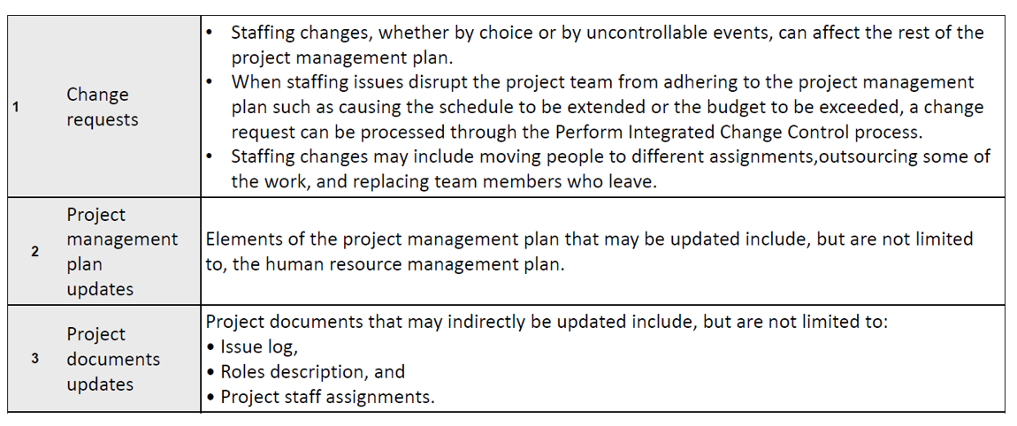
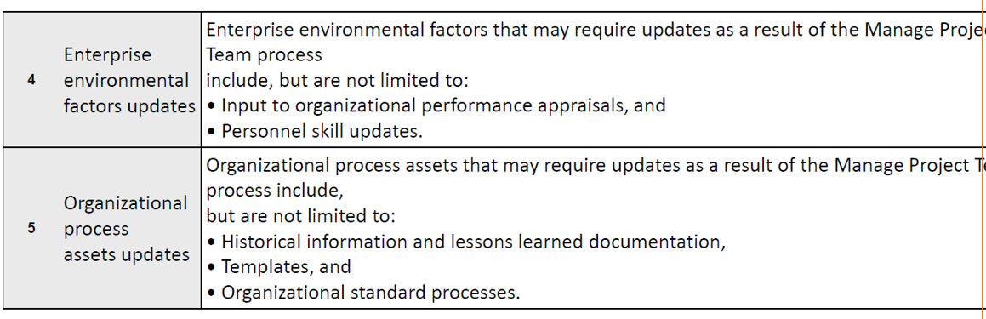

Control Resources
- Purpose: Ensure resources are available as planned and used efficiently.
- Example: Monitoring if rented testing devices are returned on time and within budget.
Key Outputs
- Resource Management Plan
- Team Charter
- Resource Breakdown Structure (RBS)
- Work Performance Reports
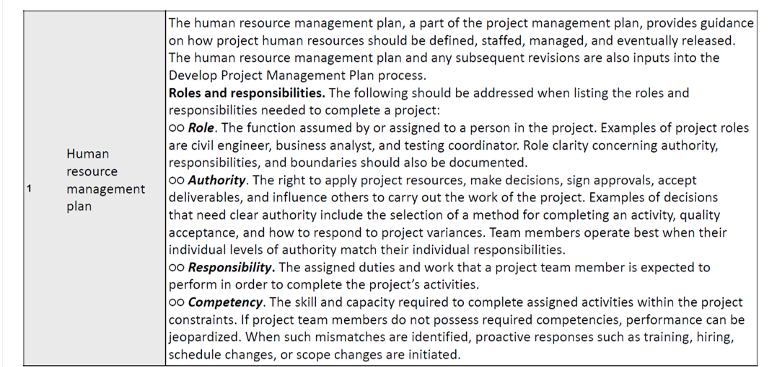
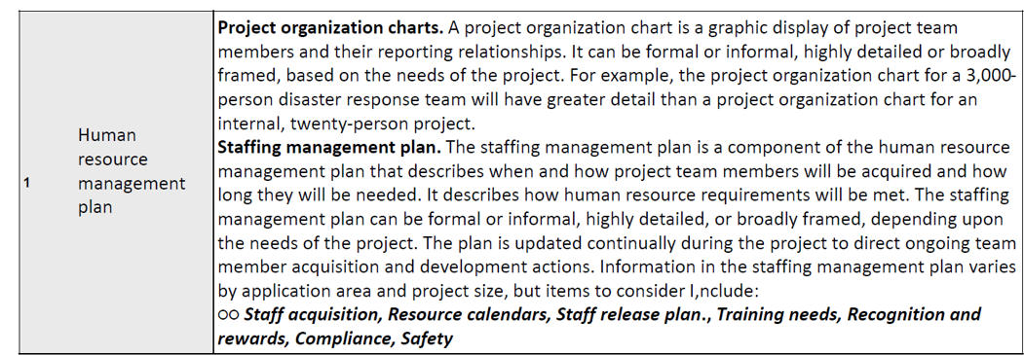
Roles and Responsibilities
- Project Manager: Responsible for team performance and resource allocation.
- Functional Manager: Provides resources.
- Team Members: Execute assigned tasks.
Tools & Techniques
- RACI Matrix: Defines roles (Responsible, Accountable, Consulted, Informed).
- Organizational Charts: Visual representation of team structure.
- Conflict Resolution Techniques: Collaborating, Compromising, Forcing, Avoiding.
Examples in Practice
- Example 1: In a construction project, creating a resource histogram to visualize labor needs over time.
- Example 2: Using a team charter in a software project to define communication norms and decision-making rules.

Team Management in IT Projects (Remote & Hybrid Teams)
Team management ensures collaboration, productivity, and alignment with project goals. In IT projects, teams often work remotely or in hybrid setups, requiring strong communication and coordination.
Challenges
- Time zone differences
- Communication gaps
- Cultural diversity
- Tracking productivity
Best Practices
- Clear Communication Channels: Use Slack, MS Teams, Zoom for daily stand-ups.
- Collaboration Tools: Jira for task tracking, Confluence for documentation.
- Defined Roles: Assign responsibilities (e.g., Scrum Master, Developer, QA).
- Regular Check-ins: Weekly sync meetings, daily stand-ups.
- Performance Metrics: Velocity, throughput.
Example
A global software development team uses Jira for sprint planning and Zoom for daily stand-ups. Time zone overlap is managed by flexible working hours.

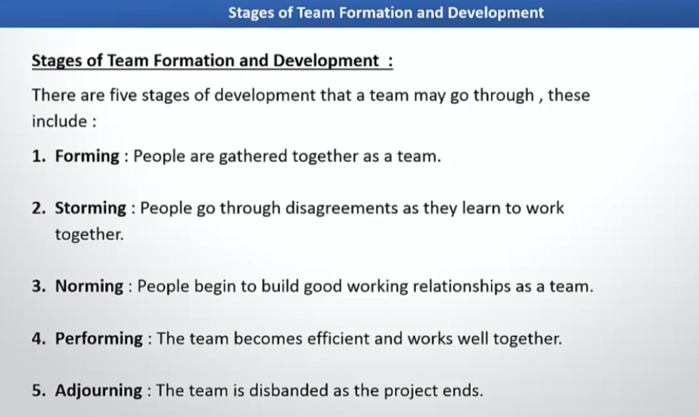
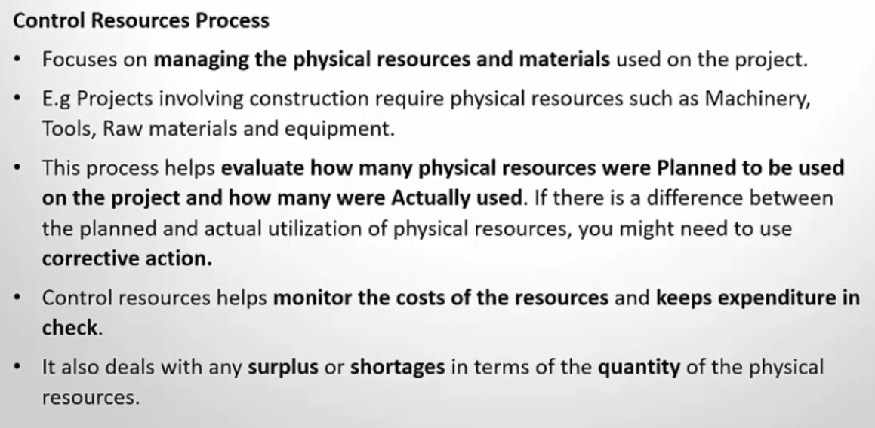
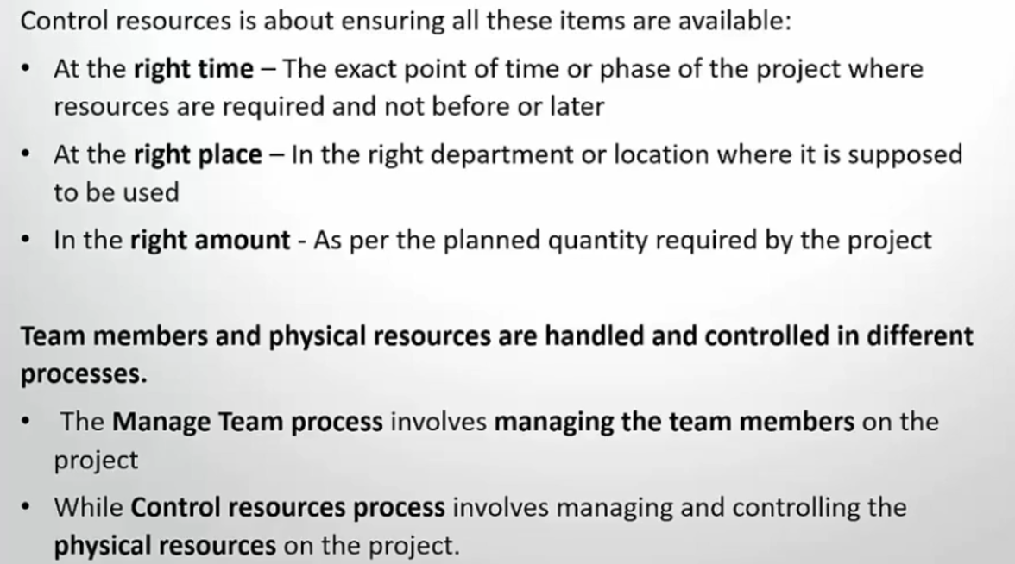
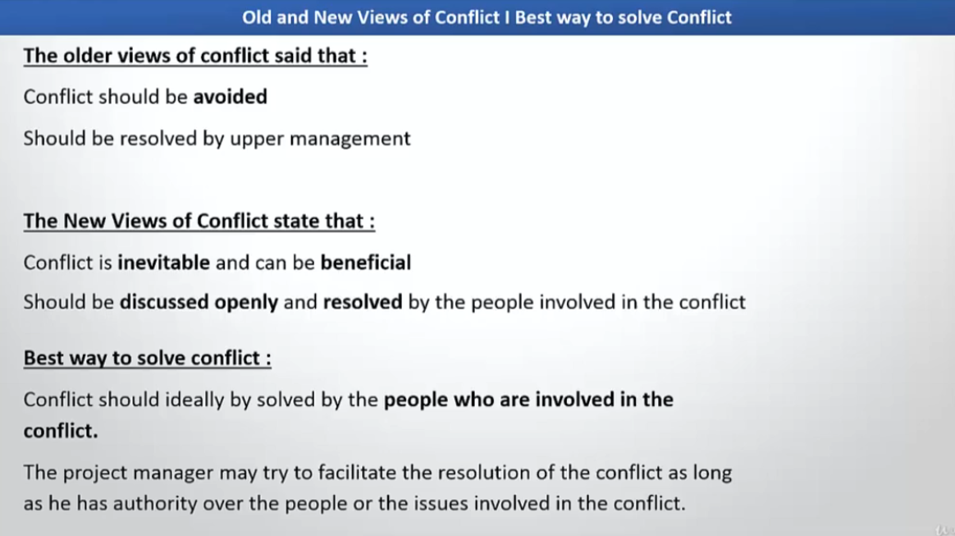
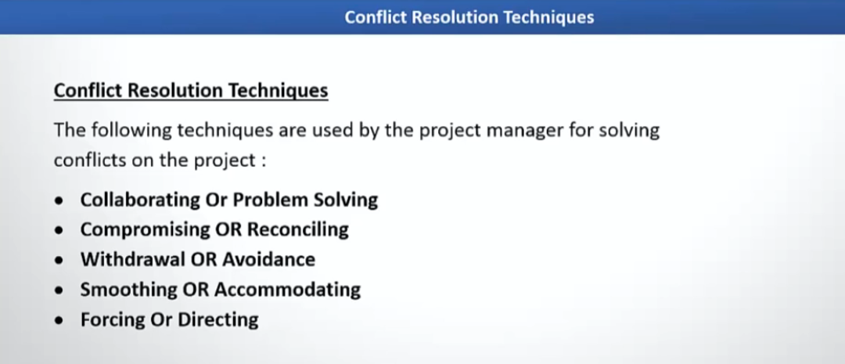
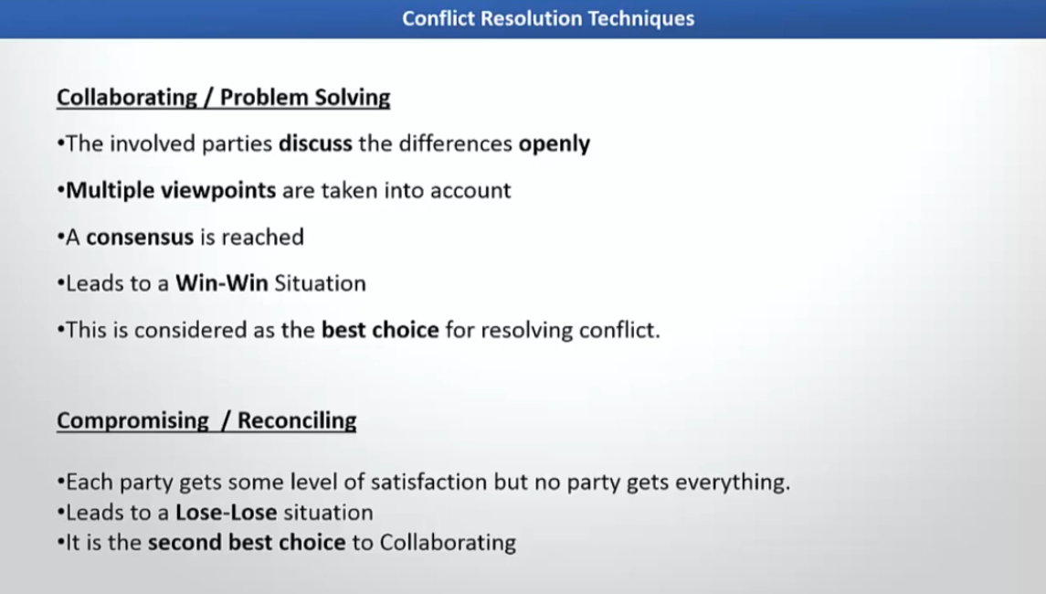
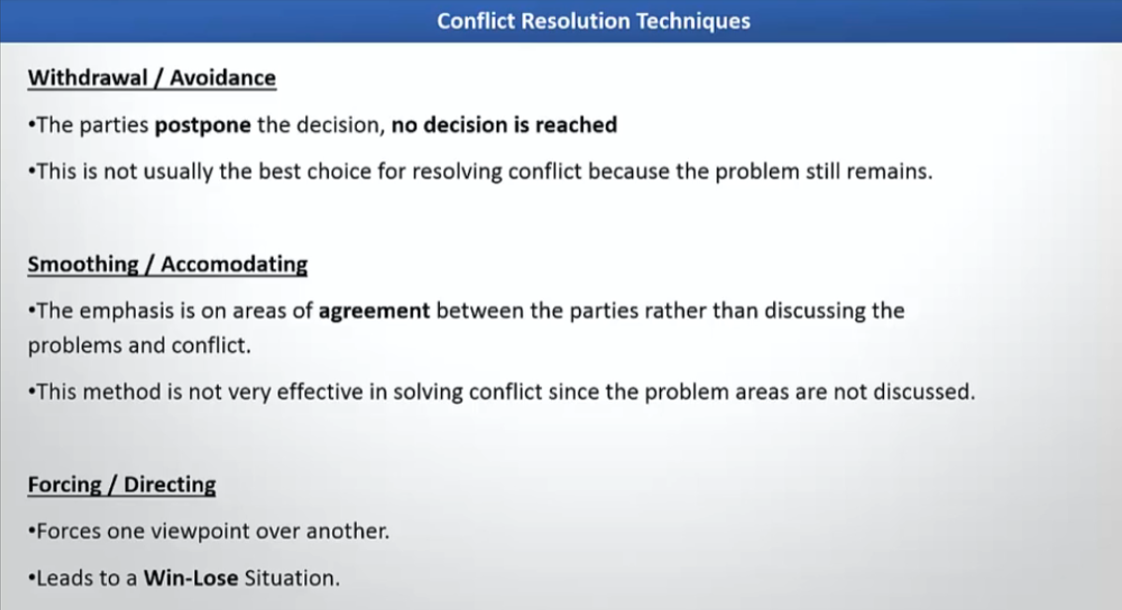

What is Conflict?
Conflict is a disagreement or clash between individuals or groups due to differences in opinions, goals, values, or interests. In project management, conflicts often arise over:
- Resources (e.g., budget, manpower)
- Schedules (e.g., deadlines)
- Priorities (e.g., feature importance)
- Technical approaches
Example: Two developers disagree on which framework to use for a project.
What is Conflict Management?
Conflict Management is the process of handling disputes and disagreements constructively to minimize negative impact and maintain team harmony. The goal is to resolve issues quickly and fairly while keeping the project on track.
How to Resolve Conflict?
PMBOK suggests using five main conflict resolution techniques:

Collaborating (Win-Win)
- Definition: Both parties work together to find a solution that satisfies everyone.
- When to Use: When the issue is critical and relationships matter.
- Example: Two teams disagree on a feature priority. They brainstorm and agree to implement a minimal viable version now and enhance later.
Compromising (Lose-Lose)
- Definition: Each party gives up something to reach a middle ground.
- When to Use: When time is limited and a quick solution is needed.
- Example: QA wants 2 weeks for testing, Dev wants 1 week. They agree on 1.5 weeks.
Withdrawal (Avoidance)
- Definition: One party retreats or avoids the conflict.
- When to Use: When the issue is trivial or emotions are high.
- Example: A developer ignores a minor disagreement about coding style to avoid escalation.
Smoothing (Accommodating)
- Definition: Emphasizing areas of agreement and downplaying differences.
- When to Use: When maintaining harmony is more important than the issue.
- Example: PM agrees with both sides partially and highlights common goals to keep morale high.
Forcing (Win-Lose)
- Definition: One party imposes a solution using authority or power.
- When to Use: When quick action is needed or safety is at stake.
- Example: PM decides to use a specific tool despite objections because of compliance requirements.
Project Communication Management involves the processes required to ensure timely and appropriate planning, collection, creation, distribution, storage, retrieval, management, control, monitoring, and disposition of project information.

Plan Communications Management
- Purpose: Determine how project communications will be planned, structured, and monitored.
- Inputs: Project charter, stakeholder register, EEFs, OPAs.
- Outputs: Communications Management Plan.
- Example: For a software project, define weekly status reports, daily stand-ups, and monthly stakeholder meetings.
Manage Communications
- Purpose: Ensure information is distributed as per the plan.
- Tools: Communication technology, performance reporting.
- Example: Sending progress reports to stakeholders via email and updating dashboards.
Monitor Communications
- Purpose: Ensure communications meet stakeholder needs and project requirements.
- Example: Checking if stakeholders are satisfied with the frequency and clarity of updates.
Communication Dimensions
- Internal vs External: Within the team vs with clients/vendors.
- Formal vs Informal: Reports vs casual chats.
- Vertical vs Horizontal: Manager to team vs peer-to-peer.
- Official vs Unofficial: Approved channels vs personal messages.
Key Components
- Communication Requirements Analysis: Identify what info stakeholders need.
- Communication Methods: Interactive (meetings), Push (emails), Pull (intranet).
- Performance Reporting: Status reports, dashboards.
Examples
- Example 1: A construction project uses a RACI matrix and weekly progress reports for clarity.
- Example 2: An Agile team uses daily stand-ups and Slack for real-time communication.
types of communication

1. Formal Written Communication
- Definition: Official, documented communication used for legal, contractual, or organizational purposes.
- Examples:
  - Project charter
  - Contracts
  - Meeting minutes
  - Official reports
  - Emails to clients with approvals

2. Formal Verbal Communication
- Definition: Structured spoken communication in official settings.
- Examples:
  - Project kickoff meetings
  - Status update meetings
  - Presentations to stakeholders
  - Conference calls

3. Informal Written Communication
- Definition: Casual written communication without strict organizational structure.
- Examples:
  - Chat messages on Slack or Teams
  - Quick notes or sticky notes
  - Informal emails between team members
  - Text messages

4. Informal Verbal Communication
- Definition: Casual spoken communication, often spontaneous and unstructured.
- Examples:
  - Coffee break discussions
  - Hallway conversations
  - Quick verbal updates during lunch
  - Brainstorming sessions without formal agenda
Great question! In PMBOK, communication methods are categorized into three main types:

1. Interactive Communication
- Definition: Two-way communication where participants exchange information in real time.
- Purpose: Ensures clarity and immediate feedback.
- Examples:
  - Meetings (face-to-face or virtual)
  - Phone calls
  - Video conferences
  - Instant messaging (real-time chat)

2. Push Communication
- Definition: Information is sent to specific recipients without expecting immediate feedback.
- Purpose: Ensures stakeholders receive necessary information.
- Examples:
  - Emails
  - Reports
  - Newsletters
  - Project updates sent via messaging apps

3. Pull Communication
- Definition: Information is stored in a central location for stakeholders to access when needed.
- Purpose: Useful for large volumes of information or when recipients choose what to access.
- Examples:
  - Project portals
  - SharePoint sites
  - Knowledge bases
  - Dashboards
✅ Why Communication is Critical in IT Projects
IT projects involve multiple stakeholders—developers, testers, business analysts, clients, and vendors. Miscommunication can lead to scope creep, delays, and cost overruns. Effective communication ensures clarity, alignment, and timely decision-making.

1. Define a Clear Communication Plan
- Strategy: Create a Communication Management Plan as per PMBOK.
- Example: For a software development project, define:
  - Daily stand-ups for the team
  - Weekly progress reports for stakeholders
  - Monthly steering committee meetings

2. Use Multiple Communication Channels
- Strategy: Combine synchronous (real-time) and asynchronous methods.
- Example:
  - Interactive: Zoom meetings for sprint planning
  - Push: Email updates for release notes
  - Pull: SharePoint for documentation and dashboards

3. Stakeholder Analysis & Tailored Communication
- Strategy: Identify stakeholder needs and customize communication.
- Example:
  - Developers get technical details via Jira
  - Executives receive high-level dashboards

4. Leverage Collaboration Tools
- Strategy: Use tools like Slack, Microsoft Teams, Jira, Confluence.
- Example:
  - Slack for quick queries
  - Jira for issue tracking
  - Confluence for knowledge sharing

5. Maintain Transparency
- Strategy: Share progress, risks, and changes openly.
- Example:
  - Publish sprint burndown charts
  - Share risk logs with stakeholders

6. Regular Feedback Loops
- Strategy: Encourage feedback to improve communication.
- Example:
  - Retrospectives at the end of each sprint
  - Client demos for validation

7. Visual Communication
- Strategy: Use diagrams, dashboards, and charts for clarity.
- Example:
  - Architecture diagrams for developers
  - Gantt charts for project managers

8. Cultural & Language Considerations
- Strategy: Adapt communication for global teams.
- Example:
  - Use simple English for distributed teams
  - Record meetings for different time zones
1. Types of Reports by Project Managers (as per PMBOK and best practices)
Project managers typically prepare several types of reports to keep stakeholders informed:
a) Status Reports
- Purpose: Show current progress against the plan.
- Example: Weekly status report showing completed tasks, pending tasks, and blockers.
b) Progress Reports
- Purpose: Highlight work completed over a specific period.
- Example: Sprint progress report in Agile projects.
c) Forecast Reports
- Purpose: Predict future performance based on current trends.
- Example: Cost forecast report using Earned Value Management (EVM).
d) Risk Reports
- Purpose: Identify and track risks and mitigation plans.
- Example: Risk register summary report.
e) Resource Reports
- Purpose: Show resource allocation and utilization.
- Example: Resource histogram for developer workload.
f) Variance Reports
- Purpose: Compare planned vs actual performance.
- Example: Schedule variance and cost variance report.
g) Lessons Learned Reports
- Purpose: Document insights for future projects.
- Example: Post-project retrospective report.

2. Reporting and Documentation Best Practices
✅ Clarity and Simplicity
- Use plain language and avoid jargon.
- Example: Instead of “velocity degradation,” say “team completed fewer tasks than planned.”
✅ Consistency
- Use standard templates for all reports.
- Example: PMO-approved status report format.
✅ Visuals
- Include charts, graphs, and dashboards for quick understanding.
- Example: Burndown chart for Agile progress.
✅ Timeliness
- Share reports as per the communication plan.
- Example: Weekly status reports every Friday.
✅ Stakeholder-Centric
- Tailor reports to stakeholder needs.
- Example: Executives get high-level summaries; team gets detailed task updates.
✅ Version Control
- Maintain proper versioning for documents.
- Example: Use SharePoint or Confluence for centralized storage.
✅ Confidentiality
- Protect sensitive data in reports.
- Example: Mask financial details for external vendors.
Here’s a role-play scenario for handling conflicts in IT project teams based on PMBOK principles and real-world practices:

Scenario
You are the Project Manager for an IT project developing a new mobile app. Two team members—Developer A and QA Engineer B—are in conflict:
- Developer A wants to release the build quickly to meet deadlines.
- QA Engineer B insists on more time for thorough testing to ensure quality.

Role-Play Steps
Step 1: Identify the Conflict
- PM: “I understand there’s a disagreement about the release timeline. Let’s discuss both perspectives.”

Step 2: Listen Actively
- Developer A: “We’re behind schedule. If we delay testing, we’ll miss the client deadline.”
- QA Engineer B: “If we rush, bugs will slip through, and the client will be unhappy.”

Step 3: Apply Conflict Resolution Techniques
Choose the best approach based on the situation:

Option 1: Collaborating (Win-Win)
- PM: “Let’s brainstorm. Can we prioritize critical test cases and automate some tests to save time?”
- Outcome: Both agree to partial testing now and full regression later.

Option 2: Compromising
- PM: “We’ll allocate 1.5 weeks for testing instead of 2, and developers will assist in automation.”
- Outcome: Middle ground reached.

Option 3: Smoothing
- PM: “Both of you want the client to be happy. Let’s focus on that common goal.”
- Outcome: Tension reduced, but issue not fully resolved.

Option 4: Forcing
- PM: “Due to contractual obligations, we must release on time. QA will test critical paths only.”
- Outcome: Deadline met, but QA feels undervalued.

Option 5: Withdrawal
- PM: “Let’s park this discussion and revisit after the client meeting.”
- Outcome: Temporary avoidance.

Best Practice
- Document the resolution in meeting minutes.
- Update the risk register (risk of defects due to reduced testing).
- Communicate the decision to stakeholders.
✅ Why Documentation Skill is Necessary for a Project Manager?
- Clear Communication
  - Documentation provides a single source of truth for all stakeholders.
  - Example: A well-written project charter avoids misunderstandings about scope.
- Accountability & Traceability
  - Every decision, change, and approval is recorded for future reference.
  - Example: Change requests documented in a Change Log prevent scope creep.
- Compliance & Audits
  - Many projects require documentation for legal, regulatory, or contractual compliance.
  - Example: Financial projects need audit-ready records.
- Risk Management
  - Documenting risks and mitigation plans helps prevent surprises.
  - Example: Risk Register ensures proactive handling.
- Knowledge Transfer
  - Documentation helps new team members onboard quickly.
  - Example: Lessons Learned report for future projects.

✅ How to Do Effective Documentation?
1. Use Standard Templates
- Adopt PMBOK or PMO-approved templates for consistency.
- Example: Project Charter, Status Report, Risk Register.
2. Keep It Clear and Concise
- Avoid jargon; use simple language.
- Example: Instead of “velocity degradation,” write “team completed fewer tasks than planned.”
3. Organize Information
- Use headings, bullet points, and tables for readability.
- Example: Work Breakdown Structure (WBS) in tabular format.
4. Version Control
- Maintain proper versioning using tools like SharePoint, Confluence, or Git.
- Example: v1.0, v1.1 for updated documents.
5. Visual Aids
- Include diagrams, charts, and dashboards for quick understanding.
- Example: Gantt chart for schedule tracking.
6. Accessibility
- Store documents in a centralized repository.
- Example: SharePoint or Google Drive for easy access.
7. Regular Updates
- Update documents as the project evolves.
- Example: Update risk register after every major milestone.
✅ How to Track Progress in IT Projects?
Tracking progress involves comparing planned vs actual performance using metrics, tools, and visual indicators. Common methods include:

1. Status Tracking
- Definition: Regular updates on completed tasks vs planned tasks.
- Example: Weekly status reports showing % completion of modules.

2. Milestone Tracking
- Definition: Monitoring completion of major deliverables.
- Example: “API integration completed by Week 4.”

3. KPI-Based Tracking
- Definition: Using Key Performance Indicators like defect density, velocity.
- Example: Agile team tracks sprint velocity (story points completed).

4. Visual Dashboards
- Definition: Real-time dashboards for stakeholders.
- Example: Jira dashboard showing sprint progress.

✅ Detailed Methods for Tracking Progress
A) Earned Value Management (EVM)
EVM is a PMBOK-recommended technique that integrates scope, schedule, and cost to measure project performance.
Key Metrics
- Planned Value (PV): Budgeted cost for work scheduled.
- Earned Value (EV): Budgeted cost for work completed.
- Actual Cost (AC): Actual cost incurred.
Performance Indicators
- Schedule Variance (SV): EV – PV
Positive = ahead of schedule; Negative = behind schedule.
- Cost Variance (CV): EV – AC
Positive = under budget; Negative = over budget.
- Schedule Performance Index (SPI): EV / PV
SPI < 1 = behind schedule.
- Cost Performance Index (CPI): EV / AC
CPI < 1 = over budget.
Example
- PV = $50,000, EV = $40,000, AC = $45,000
- SV = -$10,000 (behind schedule)
- CV = -$5,000 (over budget)
- SPI = 0.8, CPI = 0.89 → Project needs corrective action.

B) Burn-down Charts (Agile)
- Definition: A graphical representation of work remaining vs time.
- Purpose: Shows how quickly the team is completing work.
- Example:
  - Sprint starts with 100 story points.
  - Daily updates reduce remaining points.
  - If the line trends above ideal, team is behind schedule.
Benefits
- Easy visualization for stakeholders.
- Helps predict if sprint goals will be met.

Other Agile Metrics
- Velocity: Average story points completed per sprint.
- Cumulative Flow Diagram: Tracks work in progress, completed, and backlog.
What is Quality Management?
Quality Management ensures that the project meets stakeholder requirements and delivers outputs that are fit for purpose. It focuses on process quality and product quality.
Importance of Quality Management
- Customer Satisfaction: High-quality deliverables meet client expectations.
- Cost Efficiency: Preventing defects reduces rework costs.
- Compliance: Meets regulatory and contractual standards.
- Risk Reduction: Minimizes failures and downtime.
Goals of Quality Management
- Deliver outputs that meet defined standards.
- Ensure continuous improvement.
- Balance cost, schedule, and quality.
Types of Quality Management
- Quality Planning: Define quality standards and metrics.
- Quality Assurance (QA): Process-oriented; ensures standards are followed.
- Quality Control (QC): Product-oriented; verifies deliverables meet requirements.
Quality Management Strategies
- Preventive Approach: Focus on avoiding defects.
- Continuous Improvement: Use Kaizen, Six Sigma.
- Process Standardization: Follow ISO, CMMI, Agile best practices.
Steps in Quality Management (PMBOK)
Plan Quality Management
- Define quality requirements and standards.
- Example: Define code coverage ≥ 80%, response time ≤ 2 sec.
Manage Quality (Quality Assurance)
- Implement processes to ensure quality.
- Example: Conduct code reviews, enforce CI/CD pipelines.
Control Quality
- Monitor deliverables against standards.
- Example: Run automated tests, performance benchmarks.
Quality Assurance and Testing in IT Projects
- QA: Ensures processes are followed (e.g., Agile ceremonies, coding standards).
- Testing Types:
  - Unit Testing: Validate individual components.
  - Integration Testing: Check module interactions.
  - System Testing: Validate end-to-end functionality.
  - Performance Testing: Ensure scalability.
- Example: Using Selenium for automated UI testing and JMeter for load testing.
Change Management and Handling Scope Creep
- Change Management: Formal process for evaluating and approving changes.
  - Example: Use a Change Control Board (CCB) to review requests.
- Scope Creep: Uncontrolled changes to scope.
  - Strategies to Handle:
    - Clear requirements documentation.
    - Strict change approval process.
    - Regular stakeholder communication.
  - Example: Client requests extra features mid-project → PM evaluates impact and gets formal approval.
Types of Quality in IT Projects
- Functional Quality: Features work as intended.
- Performance Quality: System meets speed and scalability requirements.
- Security Quality: Data protection and compliance.
- Usability Quality: User-friendly interface.
What is Change Management?
Change Management is the structured process of handling changes in scope, schedule, cost, or quality during a project. It ensures changes are evaluated, approved, and implemented without disrupting project objectives.
Why is it Important?
- Prevents scope creep.
- Maintains stakeholder alignment.
- Ensures budget and timeline control.
- Provides traceability and accountability.
How to Do Change Management?
Follow a formal change control process:
Steps in Change Management (PMBOK Approach)
Step 1: Identify the Change
- Any stakeholder can request a change.
- Example: Client asks for an additional feature in a mobile app.
Step 2: Document the Change Request
- Use a Change Request Form.
- Include details: description, reason, impact.
Step 3: Analyze Impact
- Assess effect on scope, schedule, cost, quality, risk.
- Example: Adding a feature may require 2 extra weeks and $5,000 more.
Step 4: Review and Approve
- Change Control Board (CCB) or PM approves/rejects.
- Example: PM presents impact analysis to CCB for decision.
Step 5: Implement the Change
- Update project plan, schedule, budget.
- Example: Add new tasks in Jira and adjust timeline.
Step 6: Communicate
- Inform all stakeholders about the approved change.
- Example: Send updated project plan to client and team.
Step 7: Monitor and Document
- Track implementation and update change log.
- Example: Record change status in SharePoint.
Types of Changes
- Scope Change
  - Example: Adding new features.
- Schedule Change
  - Example: Extending deadline due to resource delay.
- Cost Change
  - Example: Increased budget for additional resources.
- Quality Change
  - Example: Higher security standards requiring extra testing.
- Resource Change
  - Example: Adding more developers to speed up delivery.
Example in IT Project
- Scenario: Client requests integration with a third-party API mid-project.
- Process:
  - Document request → Analyze impact (extra 3 weeks, $10,000) → CCB approves → Update plan → Communicate → Track.

What is Scope Creep?
Scope creep is the uncontrolled expansion of a project’s scope—features, requirements, or tasks—without proper approval, time extension, or budget adjustment.
“Small changes keep getting added, but the project plan is not updated.”

Example
A client asks for:
- Original scope: Build a login and dashboard
- Later requests:
  - Add social login
  - Add reports
  - Add mobile support
➡️ No timeline or cost change → Scope creep

2. Key Challenges Caused by Scope Creep

1. Schedule Delays ⏰
- Extra work increases effort
- Deadlines slip because the plan remains unchanged

2. Budget Overruns 💰
- More work → more resources → higher cost
- Budget becomes insufficient

3. Quality Issues ⚠️
- Team rushes to meet deadlines
- Testing and reviews get compromised

4. Team Burnout 😓
- Continuous “small” changes frustrate the team
- Leads to stress, low morale, and reduced productivity

5. Stakeholder Conflict 🤝
- Clients expect more
- Team feels expectations are unfair
- Trust issues arise

6. Loss of Project Focus 🎯
- Team shifts from core objectives
- Original goals become unclear

3. Common Causes of Scope Creep
- Poor or unclear requirements
- Weak change control process
- Stakeholders adding “just one small change”
- Lack of stakeholder involvement early
- Inexperienced project management
- Not saying “no” professionally

4. Approaches to Control Scope Creep

1. Clearly Define Project Scope 📄
- Create a detailed scope statement
- Clearly mention:
  - What is in scope
  - What is out of scope
✅ Example:
“Mobile app development is out of scope in Phase 1”

2. Strong Requirements Gathering
- Use:
  - Workshops
  - User stories
  - Use cases
  - Prototypes
- Get formal sign-off from stakeholders

3. Implement Change Control Process 🔄
Every change must go through:
- Change request submission
- Impact analysis (time, cost, risk)
- Approval or rejection
- Update project plan if approved
📌 No verbal approvals.

4. Use a Scope Baseline (PMBOK)
Scope Baseline includes:
- Scope statement
- Work Breakdown Structure (WBS)
- WBS Dictionary
This acts as the reference point for all scope decisions.

5. Prioritize Requirements (Agile Approach)
- Use MoSCoW method:
  - Must have
  - Should have
  - Could have
  - Won’t have
Changes go into future sprints, not the current one.

6. Educate Stakeholders
Explain clearly:
- Impact of changes on cost and timeline
- Trade-offs between scope, time, and cost (Iron Triangle)

7. Continuous Communication 📢
- Regular status updates
- Sprint reviews / demos
- Transparent progress reporting
Early communication prevents late surprises.

8. Documentation & Sign-Off ✍️
- Document all:
  - Changes
  - Approvals
  - Decisions
- Get written sign-offs to avoid disputes

